**CS412 Machine Learning**

# HW 2 – Probabilities – Bayesian Learning

# 100pts

* **Please TYPE your answer or write legibly by hand (pts off if it is hard to read).**
* **Use this document to type in your answers** (rather than writing on a separate sheet of paper), so as to keep questions, answers and and grades together to facilitate grading.
* **SHOW all your work for partial/full credit.**
* **Allocated spaces should be enough for your answers** (unnecessarily long and irrelevant answers may loose points)

**1) 20 pt -** Suppose that we have 3 colored boxes r (red), b (blue) and g (green).

Box r contains 8 apples, 1 oranges and 1 limes;

Box b contains 5 apples, 5 oranges and 0 limes;

Box g contains 3 apples, 3 oranges and 4 limes.

Assume a process **where we pick a box first and then pick a fruit from the selected box**. A box is chosen at random according to the following probability of being selected: p(r) = p(b) = 0.2 and p(g) = 0.6 and a piece of fruit is selected from the **chosen** box randomly.

1. 10 pt – What is the **probability of selecting an lime**?

b) 10pt - If we **observe that the selected fruit is a lime**, what is the probability that it came from the green box?

**2) 40 pt - For a 1-dimensional input space, assume we are given the following class conditional probability densities as follows:**

p(x|C1) = 1/3 for 1 <= x <= 4

0 elsewhere

p(x|C2) = 1 for 2 <= x <= 3

0 elsewhere

Assume P(C1)=P(C2)=0. 5.

1. **15pt – Draw the corresponding pdfs, being as precise as possible** (e.g. **label axes and important points on the axes**). You can draw by hand, take a picture and include here as image.
2. **10pts -** **Develop a classification strategy for a given x** (just looking at the graph – no formula), just complete the sentence(s):

`if x is in the region ........................................ , I will classify it as ….................................;

if x is in the region ........................................ , I will classify it as ….................................;

**c) 5pts -** **Draw the decision regions on the above figure.**

**d) 10pts – Give a one line qualitative answer** (no precise numbers/thresholds...) **& reasoning for each case below (**how your decision changes or whether it doesn’t).

* Would your decision strategy change if P(C1)=0.9 and P(C2)=0.1?
* How about if it was the reverse P(C1)=0.1 and P(C2)=0.9?

**3) 40pts –** **NAIVE BAYES**

**a) 15pts – Given that two random variables X and Y are conditionally independent given C, circle True or False** (2pts for each correct answer; -1pts each wrong answer):

* P(X| Y ) = P(X) True / False
* P(X | Y, C ) = P(X | Y) True / False
* P(X , C | Y ) = P(X | Y ) True / False
* P(X ,Y | C ) = P(X | C) P(Y | C) True / False
* P(X ,Y , C ) = P(X | C) P(Y | C) P(C) True / False

**b) 20pts - Using the PlayTennis data given below** (and in the lecture slides), **how would you classify x=(Overcast, Mild, Normal, Strong), using Naive Bayes classifier *without any smoothing*. Show your work** (e.g. indicate class conditional attribute probabilities under the given table in the next page and just transfer them here).

P(Yes| x) =

P(No| x) =

**Decision: ..............................**

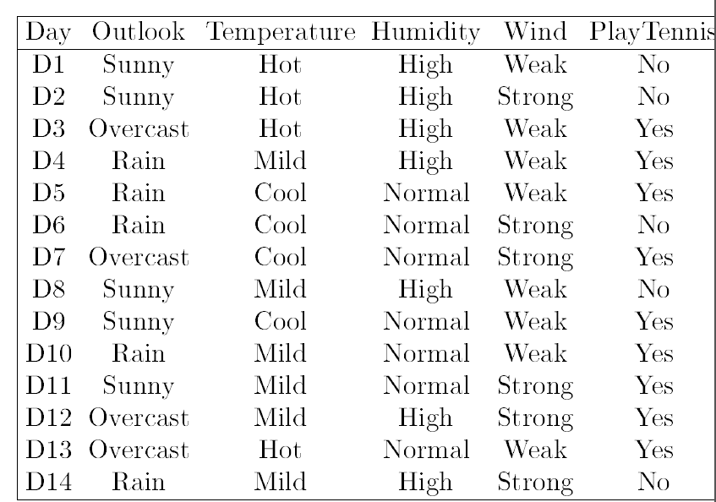

**Write here the estimated probabilities (you should only write those related to the question for simplicity):**

P(Outlook=Overcast | Yes) = .......

....

**c) 5pts - Without re-doing the whole process, give the for P(Overcast|No) and P(Temperature|Yes) using Laplace smoothing:**

P(Outlook=Overcast|No) = .......................

P(Humidity=Normal|Yes) = .........................